

AI Driven SQA: Manual & Automation Testing

Assignment 04

Module: 04
Topic: Introduction to Programming Language
with AI (JavaScript + Node.js).

Submitted by,
Name: Jhion Adbar Opi
Batch: 21
Phone: 01778812373
Q1. JavaScript Coding Practice.

01. Check whether a number is even or odd.

Explanation: This program is developed using JavaScript in the Node.js environment to check whether a user-entered number is even or odd. The program uses the built-in readline module of Node.js to take input from the user through the terminal.
First, the program creates an input interface using readline.createInterface() to receive data from the keyboard. Then asked to enter a number. Since user input is received as a string, the Number() function is used to convert the input into a numerical value.
After that, an if-else conditional statement along with the modulus operator (%) to determine the type of number. If the remainder after dividing the number by 2 is 0, the number is even or it is considered odd.
Finally, the program displays the result on the terminal and closes the input interface after completing the operation.

Source code: https://drive.google.com/file/d/1IHiROQaQ59VgLccldPHcDAjAkEFAShgk/view?usp=sharing

Output:
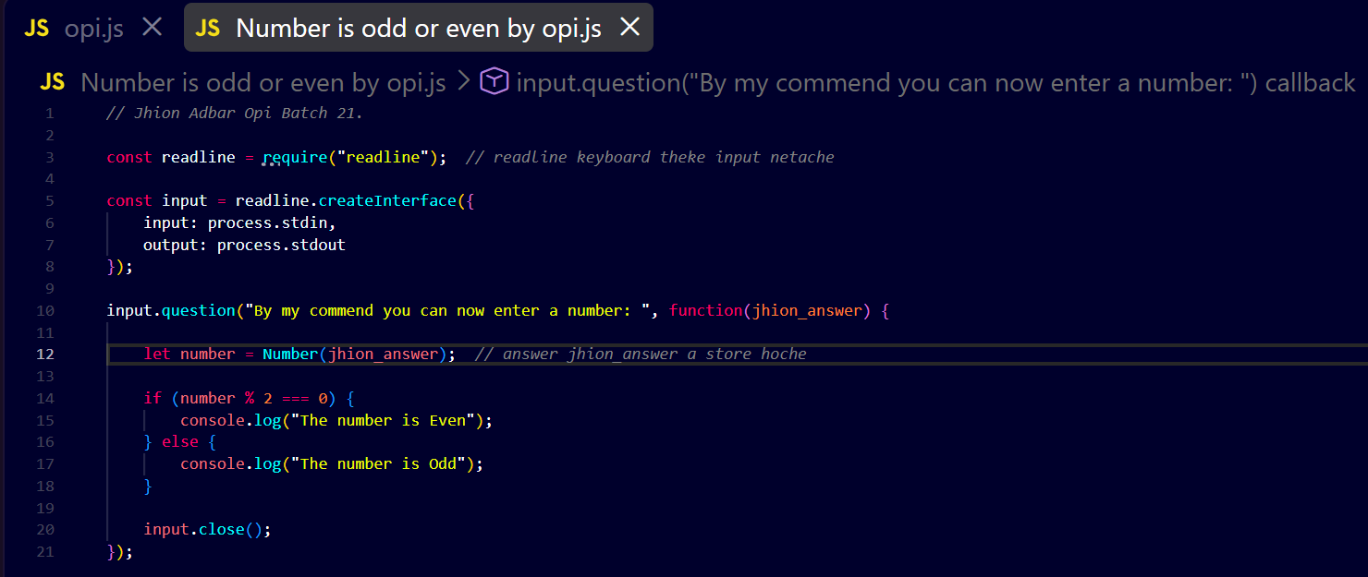

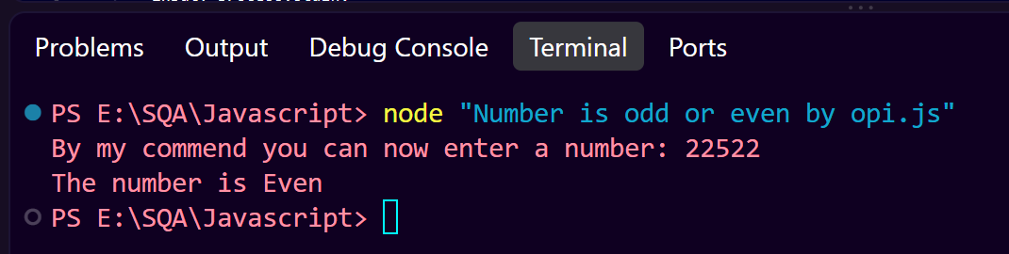
02. Find the largest of three numbers.

Explanation: This program finds the largest value among three numbers entered by the user. It uses the readline module in Node.js to collect input from the terminal. Since the entered values are received as strings, the Number() function converts them into numerical values. The program uses if-else if-else conditional statements to compare the three numbers. The logical AND operator (&&) ensures that a number is greater than or equal to the other two numbers before declaring it the largest.
Finally, the program displays the largest number and closes the input interface.

Source code: https://drive.google.com/file/d/1VBKKdW0lC83ApKW2Q2DnVkWEuLxPOYGh/view?usp=sharing

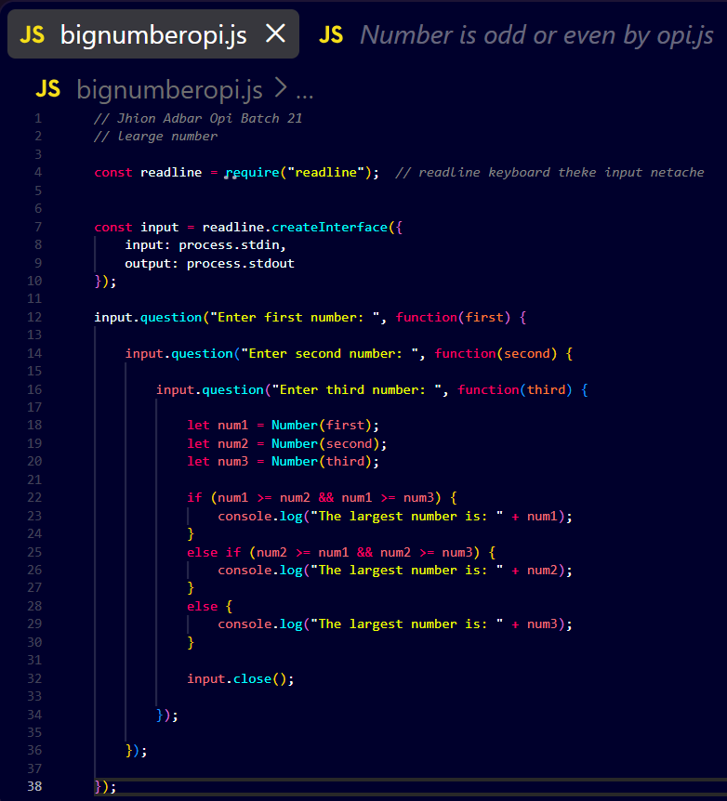
Output:
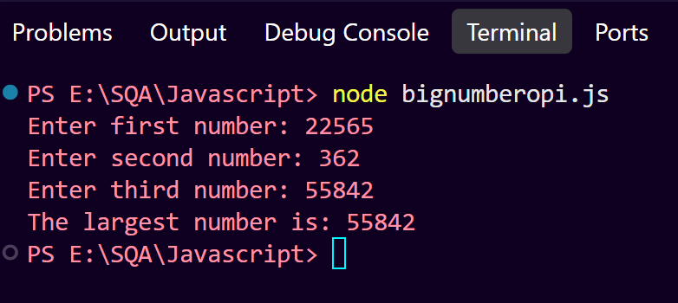
03. Reverse a string.

Explanation: This JavaScript program takes a string as input from the user using the `readline` module. The program then reverses the characters of the string using the `split()`, `reverse()`, and `join()` methods. Finally, it displays the reversed string on the console. This program demonstrates user input handling and basic string manipulation in JavaScript.
Source Code: https://drive.google.com/drive/folders/1Nk2kSCL2AB40Uu00OxxVwIM4PCV8_GTp?usp=drive_link
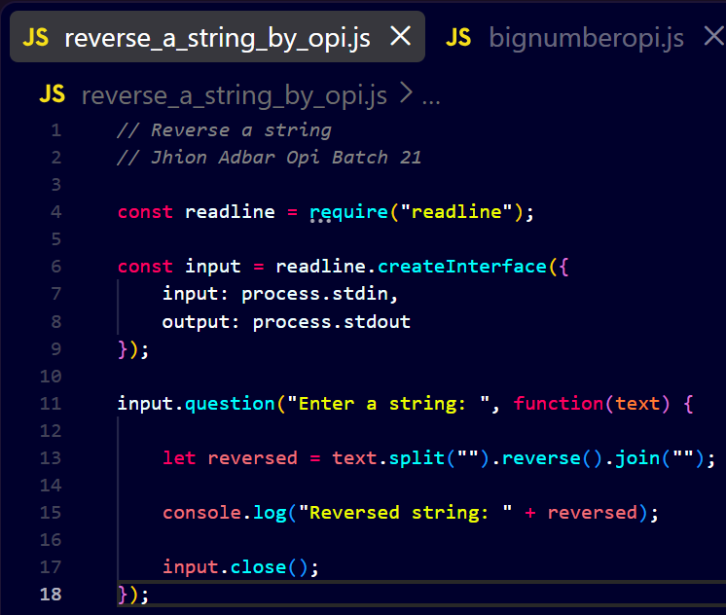
Output:

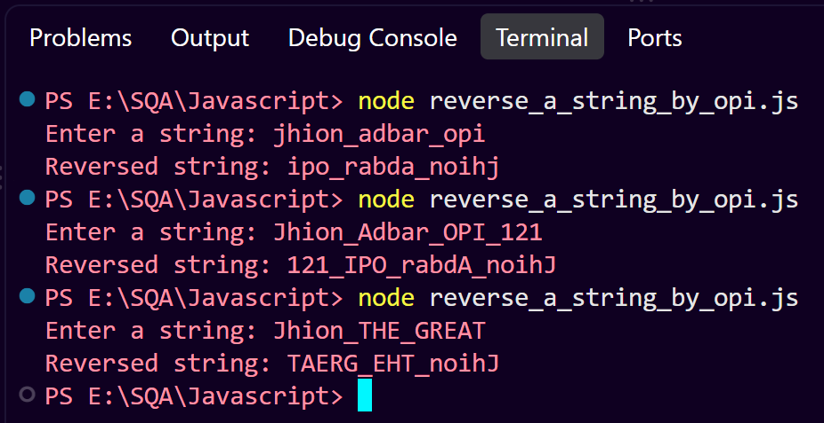
04. Count vowels in a string.
Explanation: This JavaScript program accepts a string as input from the user and iterates through each character using a loop. It checks whether the character is a vowel (a, e, i, o, u) using the `includes()` method and increments a counter when a vowel is found. Finally, the program displays the total number of vowels in the string.

Source Code: https://drive.google.com/drive/folders/1qzJJzVASNT_noyRpBN73KvPHxqDgZS8i?usp=drive_link

Output:
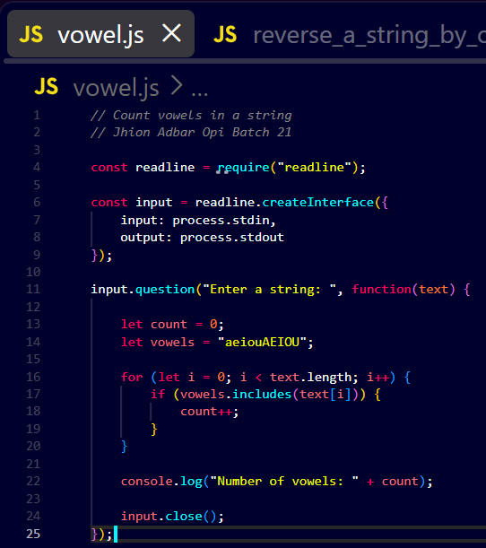

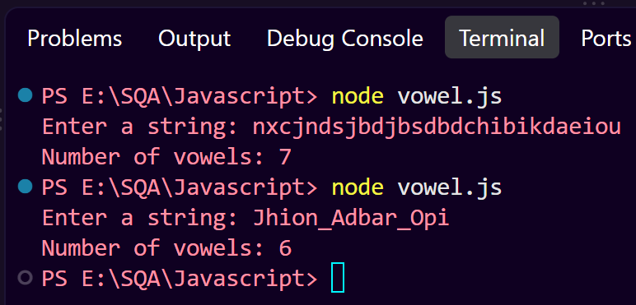
05. Remove duplicate values from an array.
Explanation: This JavaScript program removes duplicate values from an array using the `Set` object. The array elements are converted into a `Set`, which automatically stores only unique values. The unique values are then converted back into an array and displayed as the output.

Source Code: https://drive.google.com/drive/folders/1k0FPPBaiNQDb882n8-9pwxEX3uzNaLB2?usp=drive_link

Output:

